Project 5

Frederick Kelemen

2715308

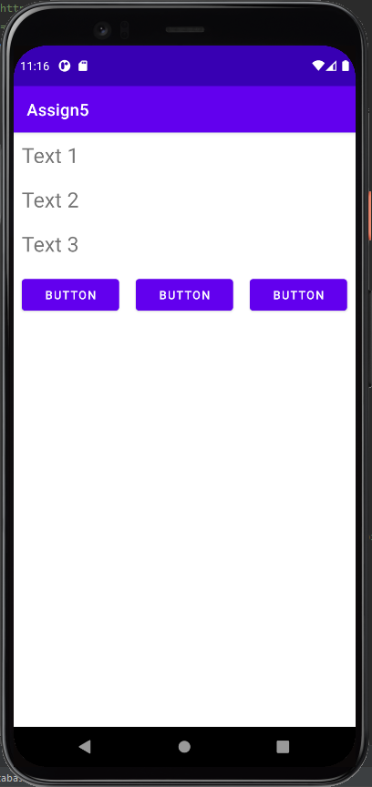Project 5 uses LinearLayout like project 4, it uses two layouts, one horizontal and one vertical, the horizontal uses weights to keep the buttons on the same row, the vertical does not.1`1`